

Haw to install the VEMS board

Thank you for ordering one of our products.

This guide will help you installing the VEMS board and it is made easy to understand just follow the instructions step by step and you will have great success.
Regards VEMS GROOP
By: Peter Jensen (Denmark)

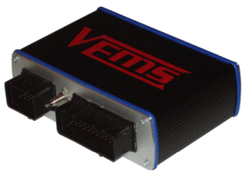

Step 1

The first thing to install is the 1R5 filter inductor red spot.
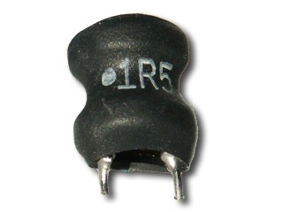

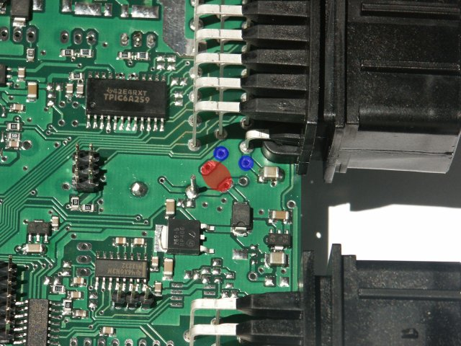

Step 2

Next to install is the Fuse near the inductor blue spot
Use a thin wire as a fuse ore use a normal wire joust
Remember to fit a 3A fuse on the power wire from the batt.
Install the GREEN wire to the stepper IC as shown
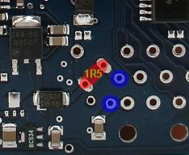
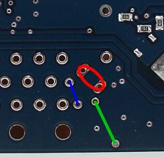

Solder side
Processor side

Step 3

If the BIG protection diode (solder side) isn’t installed from the factory then install it as shown bellow
(Remember to install it in the correct direction, the white mark againts the EC 36 connector)

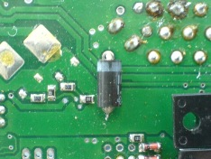

Befor
After

Step 4

Next to do is to fit the ignition Fet’s find out how many you must use for the installation
I.e. if you run disturber with one coil use one FET, for wasted spark 4 cyl, use too FET´s.
Its also possible to use one FET pr coil sequential but this setup requires too trigger input and we will not suggest to due that if this is your first installation.
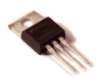

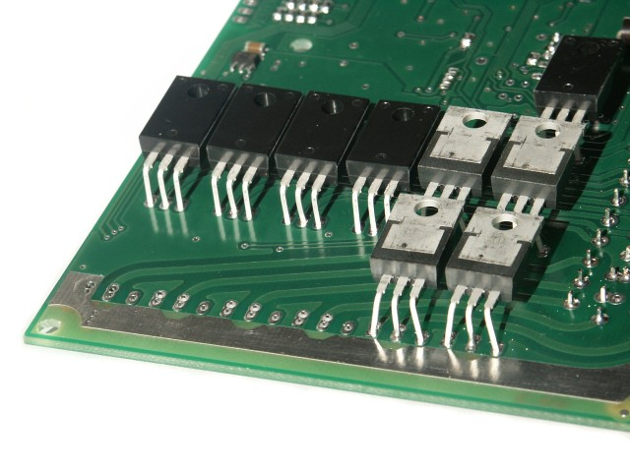

Ignition Fet

You can see the Fet´s mounted on the solder side of the Vems board

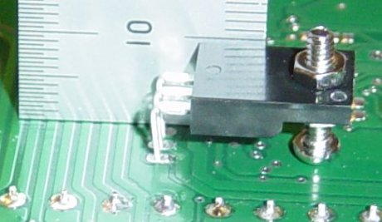

Its important to fit the FET´s correct i.e. 10 mm from the top to the pcb

Ignition FET´s are grouped 00, 01,02,03,04,05,06,07 in this picture marked RED.
Example if you have too coils i.e. wasted spark use ING 02 pin 34 and ING 03 pin 36
You can select the FET´s number, as you like.

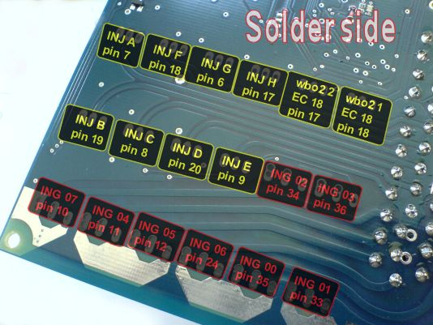

Step 5

Step 4
Step 1

Now it is time to install the Injector FET´s. find out how many injectors you have and use the same amount of FET´s

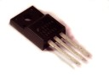

Injektor FET

Here you can see the “black” FET´s mounted on the solder side of the Vems board

Injector FET´s are grouped A, B, C, D, E, F, G, H in this picture marked YELLOW.
Example if you have four injectors i.e. four cylinders use
INJ A pin 7
INJ B pin 19
INJ C pin 8
INJ D pin 20

Step 6
Step 5

Ignition FET´s are groped 00, 01,02,03,04,05,06,07 in this picture marked RED.
Example if you have too coils i.e. wasted spark use ING 02 pin 34 and ING 03 pin 36
You can select the FET´s number as you like.

Øverst på formularen
Nederst på formularen

Flyback wire helps to avoided the FET´s getting damage and must be connected as shown see the white wire. If not you will fray the pcb
Also remember to connect pin 22 EC 36 to a switched 12 V (see the schematic for more info)
Make a wire 1,5 mm2 and install it as the white wire below

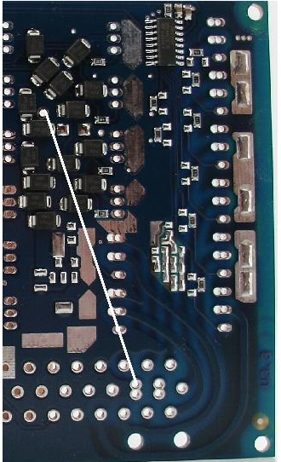

Step 7

RS 232, connection to the computer you will need to make up a serial cable.
The connection contains tree wires
Header pin 1 to Female Sub D9 pin 3
Header pin 2 to Female Sub D9 pin 2
Header pin 3 to Female Sub D9 pin 5

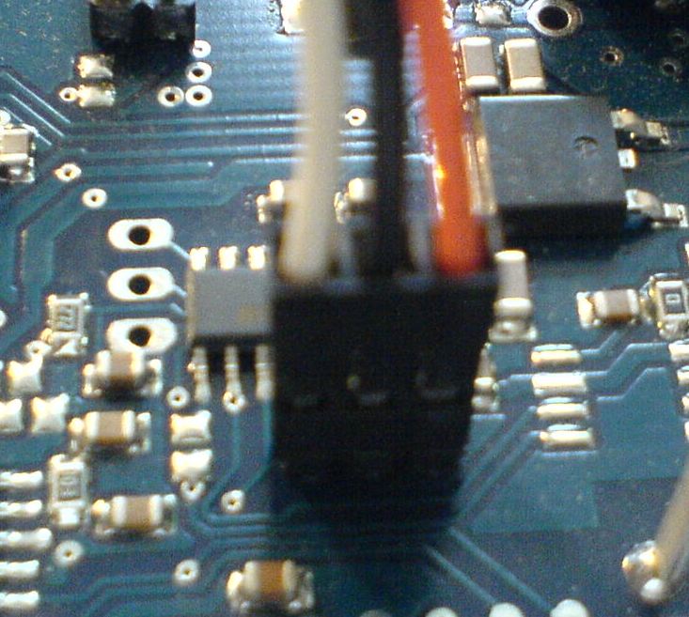
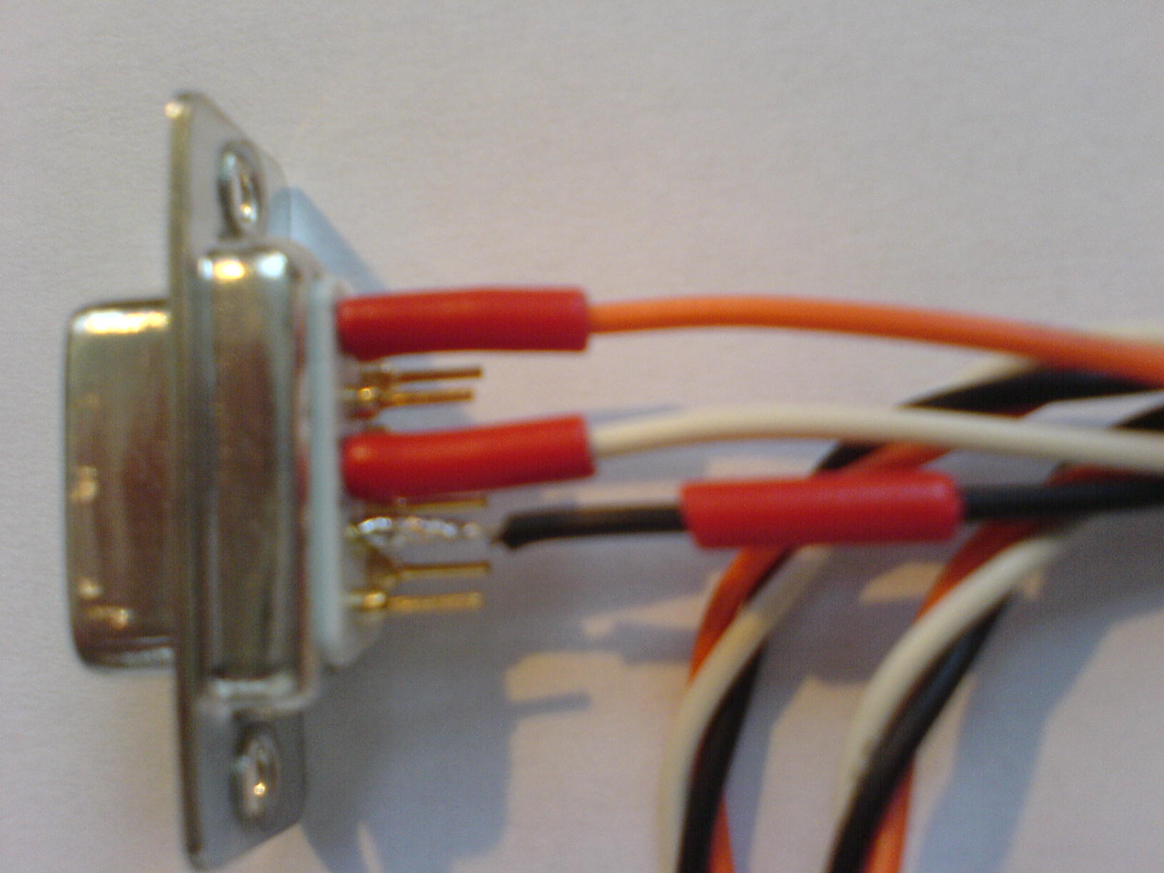

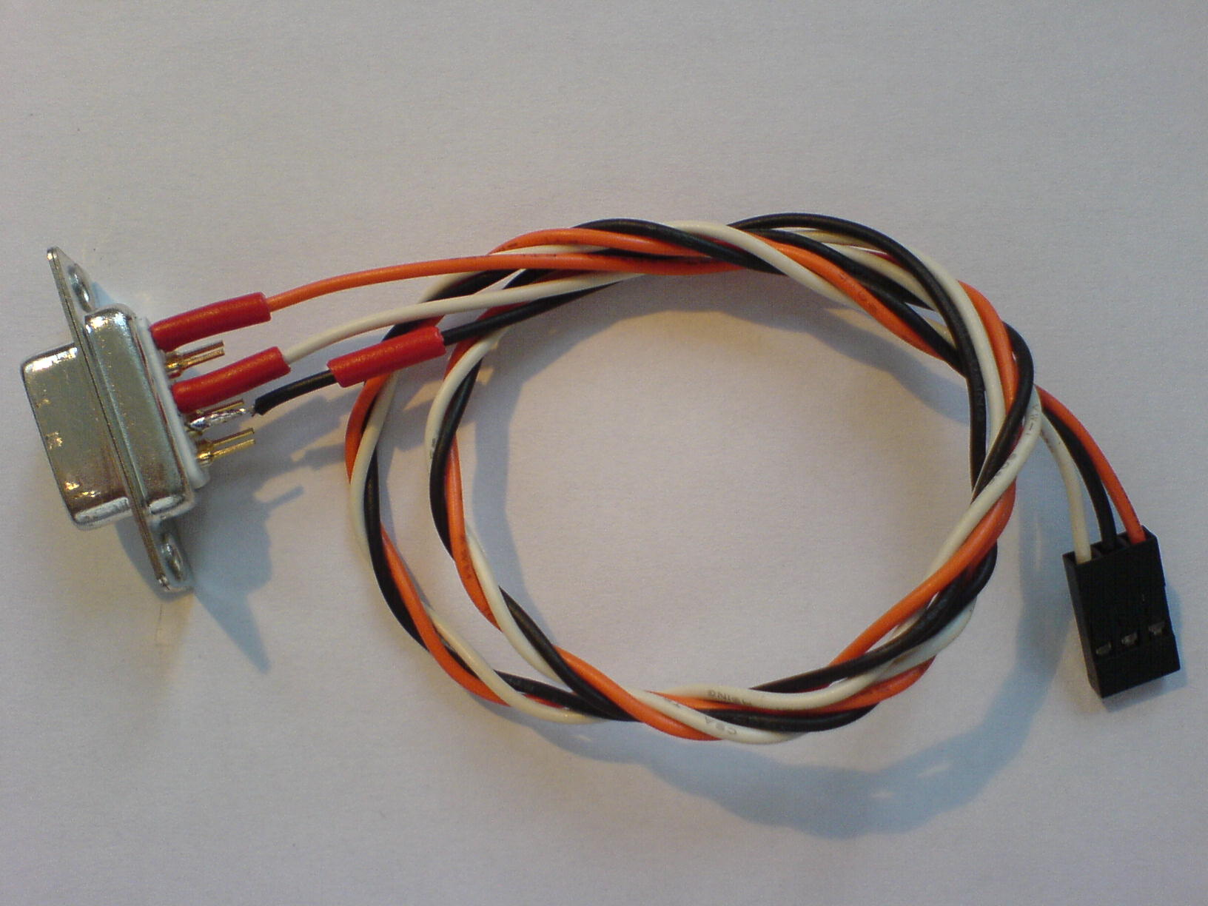

Step 8

The installation of the map sensor is quite easy; bend the legs ca. 90 degrees and mount it at the spot.
Use plastic bolts and nut to prevent short-circuit

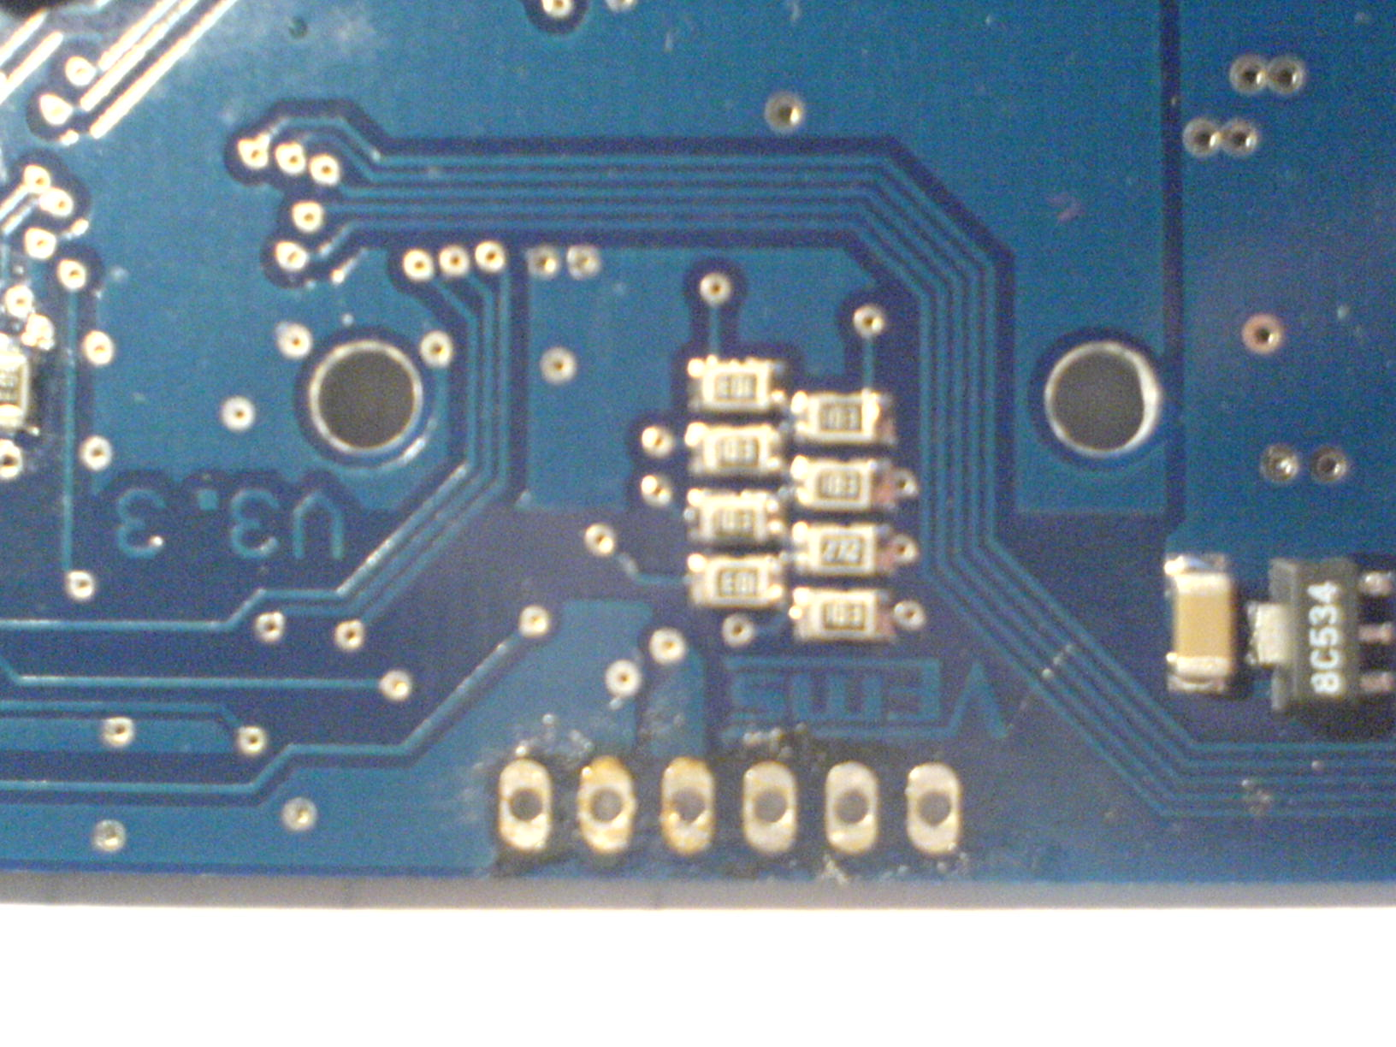
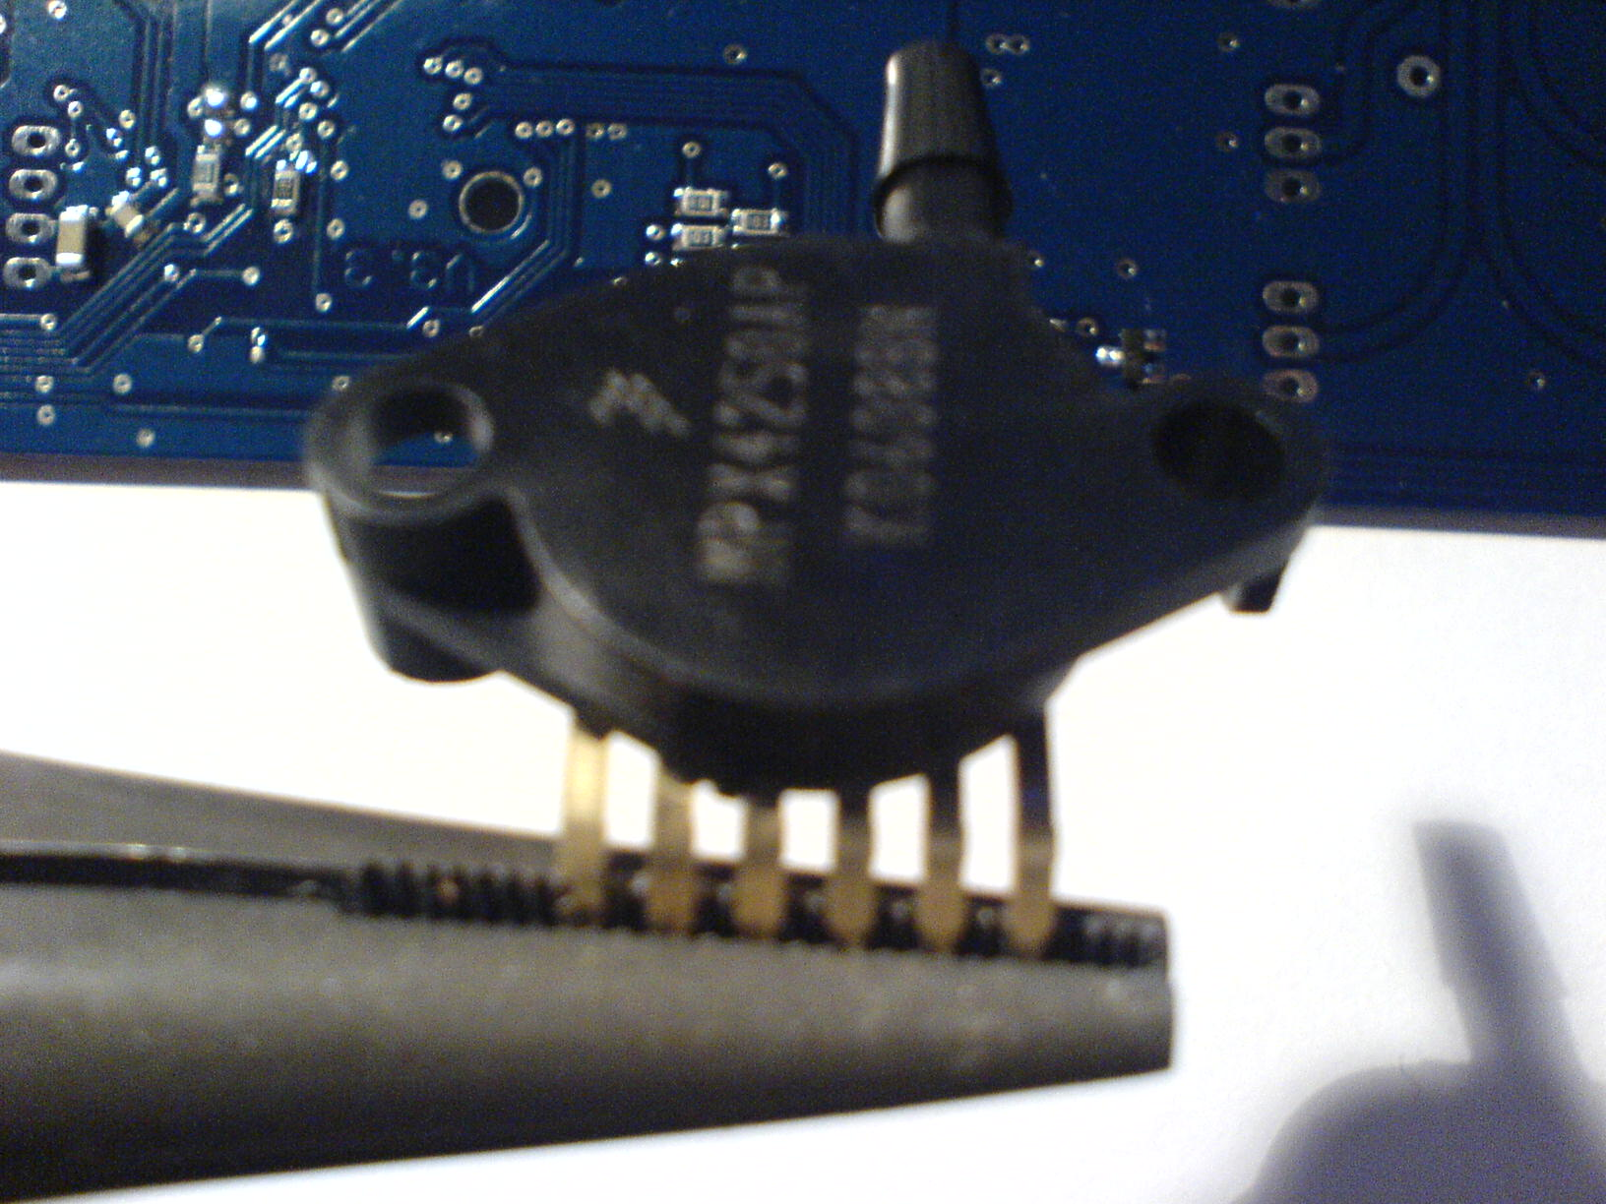

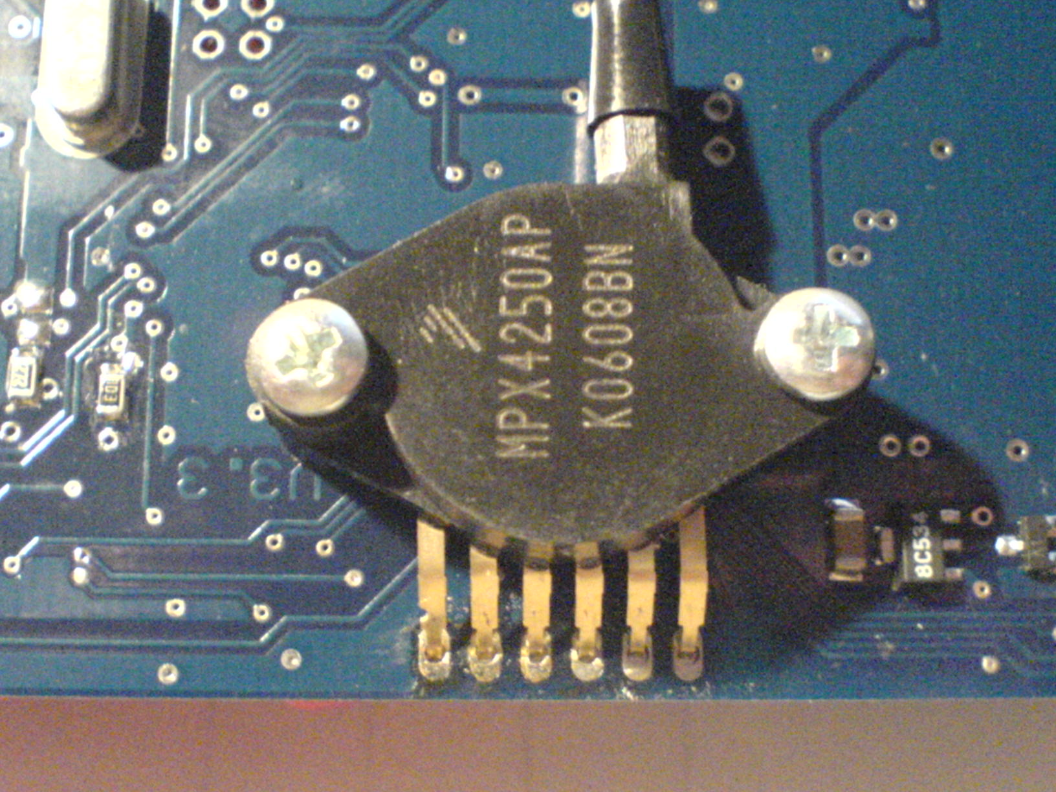

Step 9

Wideband connection

EC18-pin13 to WB6-pin1 (Nerst Cell Signal)
EC18-pin7 to WB6-pin5 (WBO2 Pump-)
EC18-pin18 to WB6-pin4 (WBO2 Heater)
EC18-pin9 to WB6-pin6 (WBO2 Pump+)

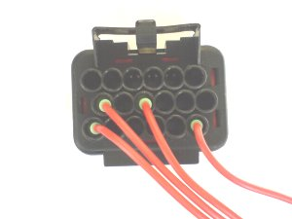
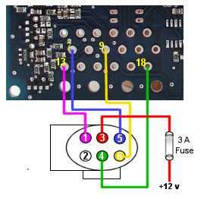

EC 18 connector

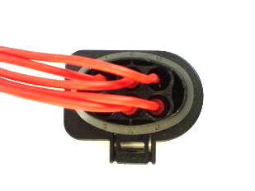
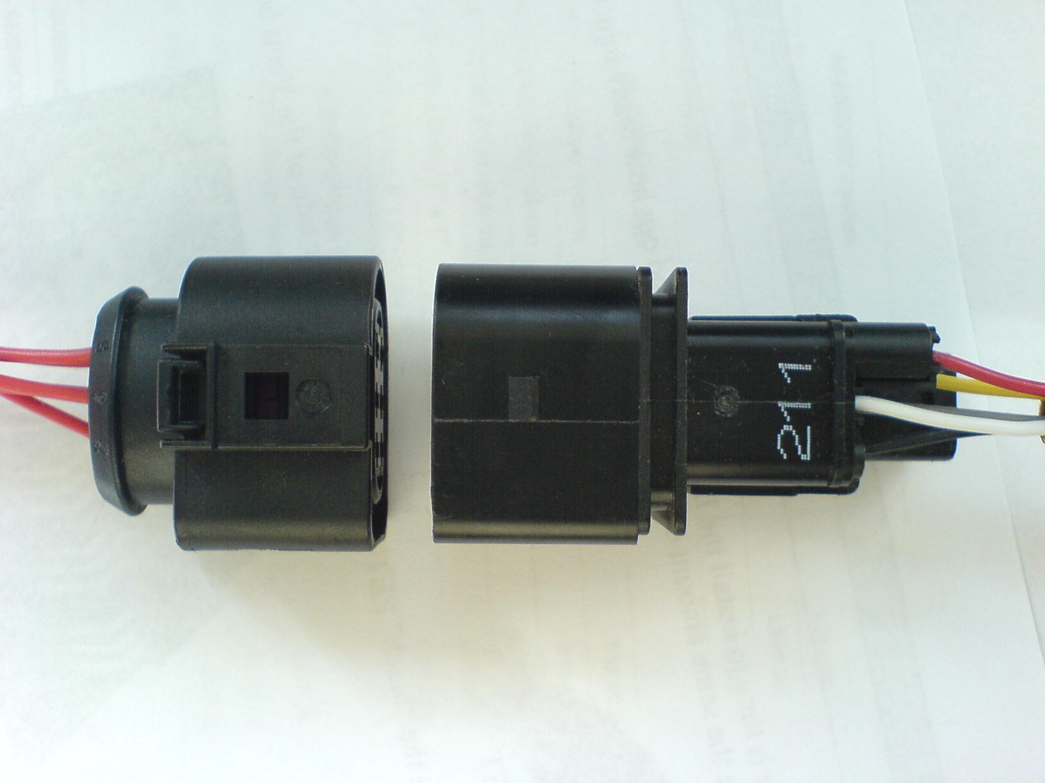

WB 6 plug
Wideband sensor connector

WB 6 plug

Step 10

When you connect the LCD Display you will need to fit two resisters, R27 and R2K7. If you use the SUB 9 connectors as shown below, DOENT ever disconnect them without turning off the power first (it will destroy some of the components on the board)

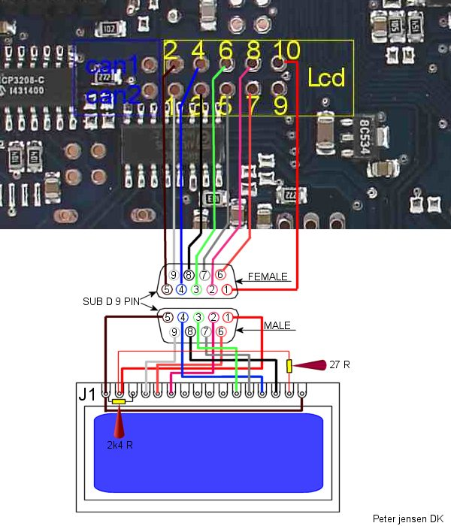

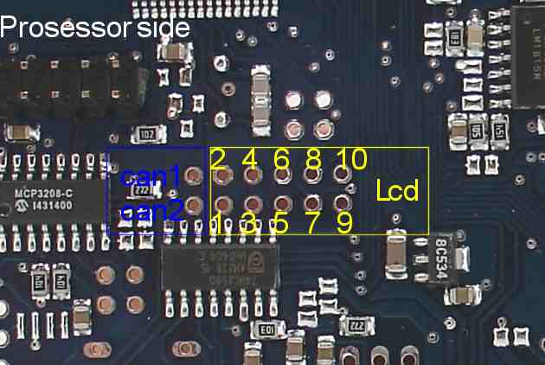
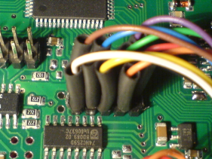

Input and output Table

Family | Number | mdh ON/OFF | Same in decimal | Pin | Name | Max Load | Comments
SPECFET | 0 | 81/01 | 1 | EC18 pin 12 | Drive A | 7 A | Misc driver
SPECFET | 1 | 91/11 | 17 | EC18 pin 6 | Drive B | 7 A | Misc driver
I259 | 0 | 82/02 | 2 | EC36 pin 35 | Drive 00 | 7 A | Ignition Driver
I259 | 1 | 92/12 | 18 | EC36 pin 33 | Drive 01 | 7 A | Ignition Driver
I259 | 2 | A2/22 | 34 | EC36 pin 34 | Drive 02 | 7 A | Ignition Driver
I259 | 3 | B2/32 | 50 | EC36 pin 36 | Drive 03 | 7 A | Ignition Driver
I259 | 4 | C2/42 | 66 | EC36 pin 11 | Drive 04 | 7 A | Ignition Driver
I259 | 5 | D2/52 | 82 | EC36 pin 12 | Drive 05 | 7 A | Ignition Driver
I259 | 6 | E2/62 | 98 | EC36 pin 24 | Drive 06 | 7 A | Ignition Driver
I259 | 7 | F2/72 | 114 | EC36 pin 10 | Drive 07 | 7 A | Ignition Driver
S259 | 0 | 86/06 | 6 | N/A | lcd_rs | N/A | Used internally
S259 | 1 | 96/16 | 22 | (Onboard) | S259 Out1 | logic | Has to be soldered
S259 | 2 | A6/26 | 38 | (Onboard) | S259 Out2 | logic | Check board layout
S259 | 3 | B6/36 | 54 | EC18 pin 4 | Step A | 1A | Can be used for stepper
S259 | 4 | C6/46 | 70 | EC18 pin 10 | Step B | 1A | Or as separate drivers with
S259 | 5 | D6/56 | 86 | EC18 pin 5 | Step C | 1A | Stepper chip populated
S259 | 6 | E6/66 | 102 | EC18 pin 11 | Step D | 1A | Otherwise, internal logic level
S259 | 7 | F6/76 | 118 | N/A | EN_ab | N/A | Used internally
P259 | 0 | 87/07 | 7 | EC36 pin 4 | Drive 08 | 350mA | Free for any usage
P259 | 1 | 97/17 | 23 | EC36 pin 16 | Drive 09 | 350mA | Free for any usage
P259 | 2 | A7/27 | 39 | (Onboard) | CL LED | 350mA | Onboard, LED1
P259 | 3 | B7/37 | 55 | (Onboard) | MISC LED | 350mA | Onboard, LED2
P259 | 4 | C7/47 | 71 | EC36 pin 3 | IDL | 350mA | Idle solenoid relay
P259 | 5 | D7/57 | 87 | EC36 pin 15 | FP | 350mA | Fuel pump relay
P259 | 6 | E7/67 | 103 | EC36 pin 31 | Drive 10 | 350mA | Free for any usage
P259 | 7 | F7/77 | 119 | EC36 pin 30 | Drive 11 | 350mA | Free for any usage

Input and output Table

Family | Number | h[0] mask | Pin | Name | Max Load | Comments
INJFET | 0 | 01/1 | EC36 pin 7 | Inj A | 10 A | Injector driver
INJFET | 1 | 02/2 | EC36 pin 19 | Inj B | 10 A | Injector driver
INJFET | 2 | 04/4 | EC36 pin 8 | Inj C | 10 A | Injector driver
INJFET | 3 | 08/8 | EC36 pin 20 | Inj D | 10 A | Injector driver
INJFET | 4 | 10/16 | EC36 pin 9 | Inj E | 10 A | Injector driver
INJFET | 5 | 20/32 | EC36 pin 18 | Inj F | 10 A | Injector driver
INJFET | 6 | 40/64 | EC36 pin 6 | Inj G | 10 A | Injector driver
INJFET | 7 | 80/128 | EC36 pin 17 | Inj H | 10 A | Injector driver

