INDUCTION BLUES:
HOW DOES IT ALL WORK?
By: Mike Wesley

In 1988 California 5.0 Mustangs, Ford switched their system of measuring air intake from Speed Density (SD) to Mass Air Flow (MAF) in order to meet the ever increasing emissions standards. In 1989, Ford switched all 5.0 Mustangs to MAF. All 4.6L Mustangs are MAF, as well. Even though MAF is a sophisticated emissions device, it can help with performance. This might sound strange as most of us relate emissions to poor performance. This is where the beauty of MAF shines through. The biggest benefit of MAF over SD is how it measures incoming airflow. With the older SD system, air pressure in the manifold was measured by a MAP sensor (Manifold Absolute Pressure). By looking at the MAP sensor and RPM, the EEC could figure out how much air was entering the engine, go to a Volumetric Efficiency (VE) lookup table and with a little math, figure out at what fuel requirement the engine is operating at. This is the main problem with SD for the person who wants to modify their 5.0. Since SD relies on a table of VE, once you go beyond it and make the engine more efficient, the EEC cannot correctly calculate the amount of fuel needed to run satisfactorily. Here is where the MAF system can help. MAF can calculate VE on the fly without a VE lookup table. This means no matter what you do to the engine, within reason, it can handle the change and correctly calculate the needed fuel. There are some problems with it, however; and we will get to those a bit later. First let's look at how MAF works.
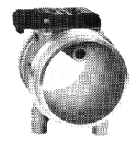
Fig 1
Fitted in the intake system, before the throttle body, is the MAF sensor itself. Commonly called the 'air meter', the MAF sensor consists of a hollow body where the majority of the air entering the engine flows through. Also in the MAF sensor is a small tube with two sensing elements exposed to the incoming airflow (fig 1). The ratio of the larger hollow body to the smaller 'sampling tube' is calculated in such a way that just the right amount of air will enter the sampling tube. The two sensors consist of very thin platinum wires wrapped around ceramic bobbins. One sensor is used to measure the temperature of the incoming air charge. The other sensor is heated to maintain 200 degrees C above the temperature sensing element. As air flows over the heated element, the element cools . Electronics in the MAF sensor vary the current to the heated element to maintain the 200 degrees C above the temperature sensing element. This change in current is directly related to the mass of air flowing over the sensing elements. The MAF electronics convert this current change into a voltage output reading which is sent to the EEC. Inside the EEC there is a transfer function that converts MAF voltage to an airflow value (fig 2). By using this lookup table, the EEC can tell how much air is entering the engine at any given time. Also inside the EEC, there is a calibration parameter that refers to the size of the injectors installed in the engine at 39 PSI. Stock 5.0 and 4.6L 2V Mustangs were originally equipped with 19# injectors. The 5.0L / 5.8L and 4.6L 4V Mustang Cobras came with 24# injectors. When relating MAF sensors and injector size, one of the biggest misconceptions about the MAF system is that the MAF is 'calibrated' for a given injector. This is only true with aftermarket MAF sensors like the Pro-M, C&L / Vortec and Auto Specialties air meters, not the stock Ford air meters. What Ford does, is select a MAF sensor and inform the EEC about it by calibrating the airflow Vs voltage transfer function with data obtained from a flow bench. Then they determine how much fuel the engine will require under worst case scenarios, select an injector size, and put that value into the EEC calibration. The MAF sensor and injector size are basically un-related which means a stock 5.0 Mustang's MAF sensor IS NOT calibrated for 19# injectors - the EEC is. Now that the EEC knows what air meter it has and what injectors are being used, it can correctly calculate how much to pulse the injectors to get the desired fuel flow. In simple terms, here is how the EEC figures out how much to pulse the injectors.
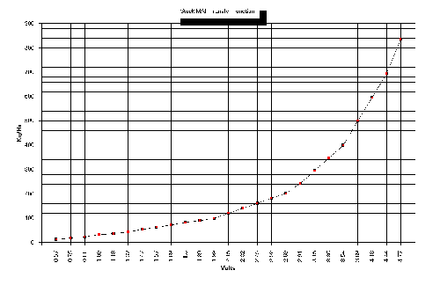
Fig 2
the engine runs, the EEC looks at the air meter voltage and converts this to an airflow value. This airflow value is used to calculate a term called Load. Load is roughly VE and is determined by the ratio of incoming air over how much the engine can hold. If the air meter tells the EEC it is measuring 50 CFM of air and the engine can hold 100 CFM, then 50 / 100 = .5 (Load) or 50% (VE). Actually, the EEC doesn't measure in CFM, since CFM is a VOLUME measurement and the MAF sensor measures the incoming air by MASS. CFM is a bit easier to understand and the result is the same. Now that the EEC has the Load value, it can go to it's fuel lookup tables and get the A/F ratio the engine should be operating at based on Load and RPM (fig 3). With this number, and by using some math, it figures out how much pulsewidth to give the injectors based on how much air is entering the engine. Since it knows both airflow and injector size, it's not that difficult a task. The more air, the more fuel is needed which means the injectors need to be pulsed at a larger pulsewidth. This applies in Open Loop mode only, where the EEC isn't looking at the O2 sensors. During Closed Loop where the EEC IS looking at the O2 sensors, the A/F lookup table is not used. The O2 sensors basically tell the EEC what A/F ratio it needs to run at. Of course there is a lot more to this whole situation as the EEC must also do compensations for things such as engine coolant temp, intake manifold temp, barometric pressure and the accelerator pump, because they all affect how much fuel is needed. We won't go into all of the compensation routines in this article, since it would make things way to complex for the scope of this one article.
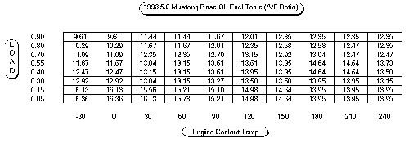
Fig 3
Now understanding how the EEC handles fuel, lets look at spark advance. Load is also used in the spark calculations. There are lookup tables that tell the EEC how much timing to run at any given Load and RPM (fig 4). Again, the EEC looks at the MAF sensor, converts the voltage to an airflow value and ratios that over how much the engine can hold inorder to arrive at a Load (VE) value. It then uses this as an input for the spark tables. If you notice by looking at fig 4, an engine operating at lighter Loads, or lower VE, requires a lot more spark advance to operate efficiently.
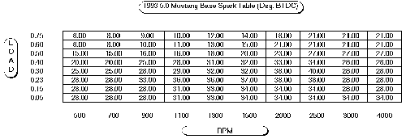
Fig 4
Getting back to the MAF sensor itself, the original 5.0L Mustang air meter is SMALL! Roughly 55mm in diameter and is a restriction in the intake system. 5.0L Cobras and 4.6L 2V Mustangs use a 70mm MAF sensor which is much better and the 5.8L Cobra R and 4.6L 4V Cobra use an 80mm MAF sensor which is rather big and doesn't pose a real restriction until you massively increase the airflow capacity of the engine. As far as MAF sensors go, the 55mm sensor on a 5.0L Mustang should be the first thing to go, as it can limit the amount of power the engine is capable of making. A larger diameter air meter will create less of a pressure drop and be less restrictive. Although you can make lots of power with the stock air meter, it's generally a good idea to swap it out for a larger piece. How much power can you get with the stock MAF? Well, I have gotten 400+ HP using the stock MAF, but that took a significant amount of time and effort calibrating the EEC with some special tools I developed. My car went 11.51 @ 118 Mph with the stock 55mm MAF sensor. Although, I have recently switched to a larger 80mm Ford air meter and went 11.21 @ 122. I knew the stock MAF sensor was a restriction, but I was trying to prove a point - and I think I did!
There are various manufacturers of aftermarket MAF sensors, in various sizes, but they all work the same way. They attempt to fool the EEC, except for one system I designed for Kenne Bell which doesn't. All this fooling around can be good, or it can be bad. I'm sure you've heard about someone installing larger injectors, a 're-calibrated' MAF sensor, and having driveability problems. Things like surging, poor economy, black smoke coming out of the tailpipes, and part throttle detonation or blown head gaskets from running too lean. These are caused by aftermarket MAF sensors re-calibrated for larger injectors. I'd estimate that 60% of Mustang owners who use these aftermarket MAF meters have one or more driveability problems. Aftermarket MAF sensors calibrated for stock injectors don't really have much of a problem most of the time, but can under certain situations. Let's look at how the aftermarket sensors do their job (or don't do their job) to see why.
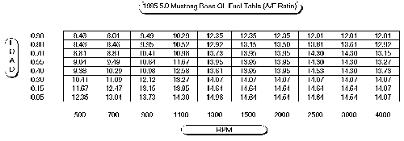
Fig 5
Figure 5 details what the transfer function for a stock Ford 55mm MAF sensor looks like. As you can see when airflow increases, the amount of voltage also increases. If you were to install 30# injectors into a 5.0 Mustang and not re-calibrate the air meter or the EEC, it would run way to rich and pump out lots of black smoke. The reason for this is because the EEC still thinks it has 19lb injectors installed, which flow much less fuel at any given pulsewidth than the 30lb injectors. So when the EEC goes through its calculations to figure out how much to pulse the injectors, way too much fuel will be injected. Here's the trick the aftermarket MAF people do (not including Kenne Bell which is calibrated in the same fashion as the stock Ford MAF is). Since the EEC looks at the MAF sensor voltage to determine airflow, what if we were to fool the EEC into thinking it had less air coming in, therefore it would calculate a smaller pulsewidth? Bingo! That's exactly what they do. There are a couple different ways to accomplish this. One way is how Pro-M and Ford Motorsport do it. They open up the electronics on the MAF sensor and modify the circuit to lower the output voltage of the MAF sensor. The shape of the voltage airflow curve remains the same (hopefully), but it is shifted down by a ratio of old injector over new injector. This means the output voltage curve of the MAF electronics is scaled by the ratio of the two injectors. In our case we had 19#'ers and switched to 30#'ers (19 / 30 = .63) which means the new curve is only 63% of the old curve. Fig 6 shows this graphically. Now when the EEC looks at the voltage, it now thinks it's getting less air, and less air means less fuel needed, so it will calculate a smaller pulsewidth which is hopefully close enough to deliver the right amount of fuel.
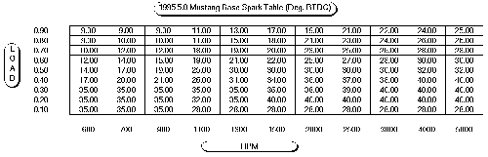
Fig 6
Another method of fooling the EEC is the way C&L/Vortec do it. By changing the ratio of the main bore of the MAF sensor to the sampling tube, you can make the MAF look like it's getting less airflow too. These MAF's use the stock MAF electronics and vary the output voltage curve mechanically. The last way I have seen to fool the EEC is the way Auto Specialties does it. Their method is similar to C&L/Vortec, but they also use a screw positioned in the sampling tube in order to fine tune the bore to sampling tube ratio. By moving the screw in and out, you change the ratio. Each of these methods looks like it should work well, in theory. There is a problem with fooling the EEC in this way and it's called Load. Remember Load is calculated by the ratio of incoming air to how much the engine can hold. Well, now the incoming air information is all wrong so the Load calculation is all wrong also. Since Load is used to determine what A/F ratio and what spark advance to run at any given RPM, you can probably guess that with a re-calibrated air meter you no longer run correct fuel and spark - and you'd be right! By looking back at fig 4, you'll see the RPM Vs Load spark table and if you notice as you go up in Load, the amount of spark advance goes down. With the 30# re-calibrated air meter installed, Load is going to be roughly 35% less than what it actually is. What you end up with is at some RPM / Load points your running more spark advance which is like bumping up the base timing and makes the car a bit quicker. At other RPM / Load points the spark is so over advanced you can get surging, detonation at part throttle or just plain slow down. Look at fig 4 with the spark table for a 93 5.0L Mustang. Go to 1500 RPM and let's say the engine is operating at a true .60 Load, but the re-calibrated air meter is tricking the EEC into thinking it's only running at .40 Load (roughly 35% lower than actual). Notice that the base spark advance is a whopping 17 degrees over advanced! That's just like setting your base distributor timing at 27 degrees!!! At Wide Open Throttle on a 93 5.0L Mustang, the over advanced situation goes away since the EEC only uses RPM to figure out spark advance, but the SN-95's use Load ALL THE TIME! Now look at fig 3 to see how it can affect fuel on a 93 5.0L Mustang. Let's say we are running 180 degrees engine coolant temp and .70% load. Normally we would want to run somewhere around a 13.04:1 A/F ratio, but since Load is goofed up we actually run near 14.64:1 which is quite a bit leaner than you'd want to be. Figs 5 and 6 show a 95 5.0L Mustang fuel and spark table. Ever wonder why the SN-95 cars seem to be a bit more tricky to get running good? Now you know.
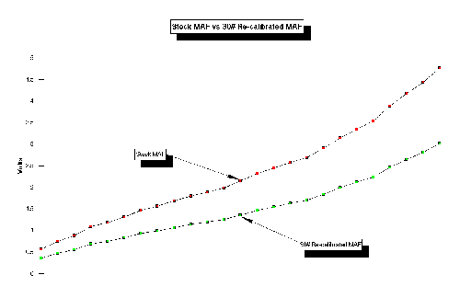
Fig 7
The larger the injector the MAF is calibrated for, the worse everything gets since the error in the Load calculation gets bigger and bigger. Now these problems don't happen to everyone and hopefully I didn't scare anyone by writing this. But if you are experiencing derivability problems and you have a re-calibrated MAF, now you know the reason why it runs like it does. Now there is a benifit of having a MAF sensor re-calibrated and it's sort of a side effect of the process. If you run a stock air meter on an engine that can really pull a lot of air, such as those with a supercharger, you can peg the MAF sensor's electronics. Depending on what year Mustang you have, the 'peg' voltage is somewhere around 4.85 or so volts. The EEC will look at this voltage and think there is something wrong. The check engine light will pop on and depending on how your engine is set up, you could blown a head gasket or worse. What happens is the EEC will think the MAF sensor is bad and use a default air charge table to get it's airflow values based on throttle position and RPM. Normally this table is calibrated so the engine will run richer than normal which doesn't do any harm. But if your pushing lots of boost, it might not be enough fuel. Since the re-calibrated MAF sensor's voltage curve is now lower than the stock one, it takes an awful lot of airflow to peg the meter. That's the good side effect from this type of MAF re-calibration!
Hopefully, this clears up some of the misconceptions about how the Ford MAF system works. If you have any further questions, feel free to e-mail me by click my name above and I'll be glad to answer any further questions you might have.

