VEMS v3 genboard checklist before final assembly (srl 9900-10499)
If your VEMS v3 genboard’s serial number is 9900-10499 please follow these instructions during assembly. On assembled ECUs normally done when applicable, but check if converting (eg. adding 3rd trigger or mcp3208/ch5 analog input).
- Check reset circuit. Solder the components if not already populated (for lower „reset impedence” and better noise suppression eg. during powerup):
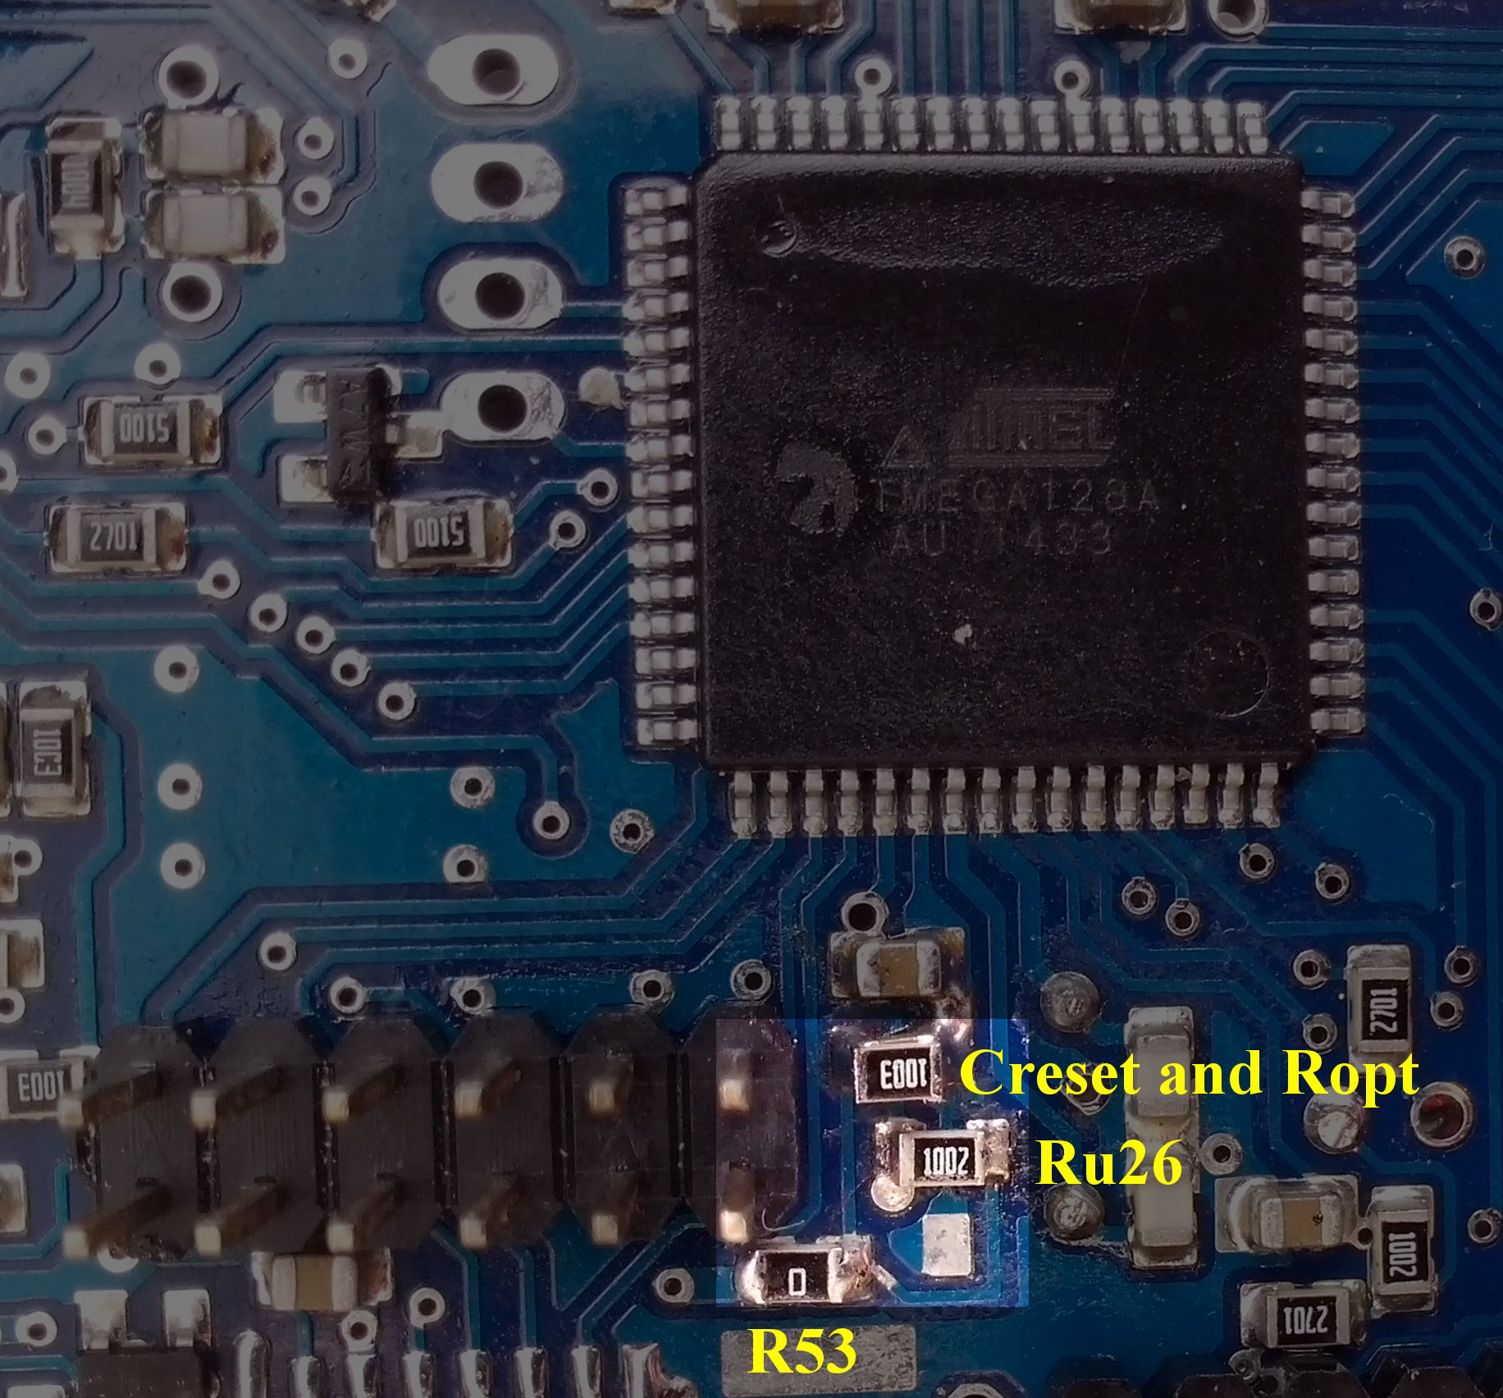
Creset = 1uF (parallel with Ropt, under Ropt on the picture). The only mandatory component.
Ropt = 100k is optional, piggybacked on top of Creset (Creset is required!)
Ru26 = 10k reset pullup (can be higher value, or left off if Ropt is not populated either)
R53 = 0R (or 1k). Already populated (do NOT remove).
Alternatively (for 120msec or larger delay), see how MCP131 or MAX809 or MCP809 can be applied: http://vems.hu/download/v3/doc/assembly/v3_mainboard_resetChips_variants.pdf
- Check SCK pullup required. Solder the components if not already populated. (on ISP header, bottom side)
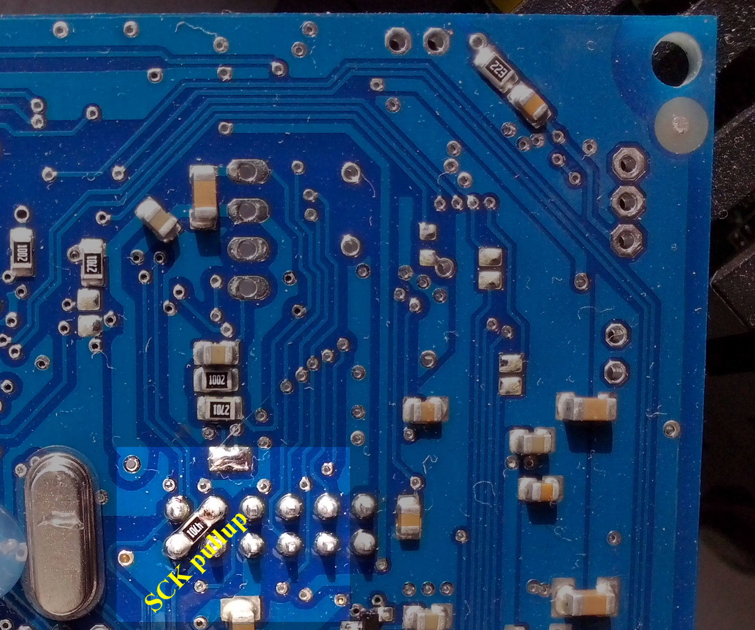
SCK pullup = 4k7 diagonally on ISP header, bottom side

- Check Analog in mcp3208/Ch5’s input filter capacitor C113 (above the unpopulated „midopa” IC). If missing, solder C113=220nF:
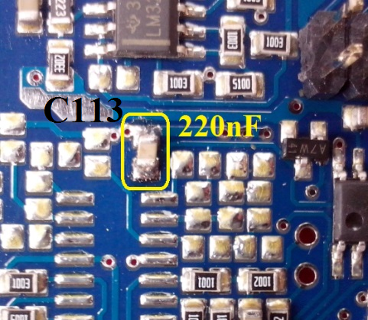

- If using Third trigger, on bottom side change C105 capacitor to 1nF (originally soldered 220nF; already 1nF if ECU was ordered with 3rd trigger):
