3rd Trigger input (genboard v3.8)

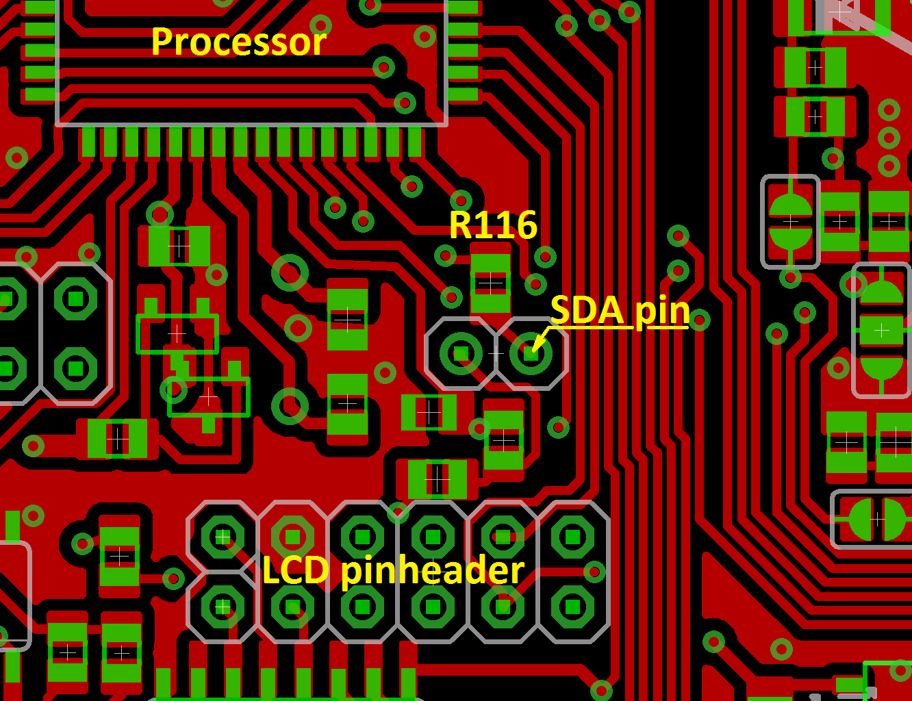
Top side:
- „SDA pin” is 3rd trigger sensor input (pull to GND, or apply 0/5V signal)
- R116 - 2k7 Pull-up resistor (to +5V)

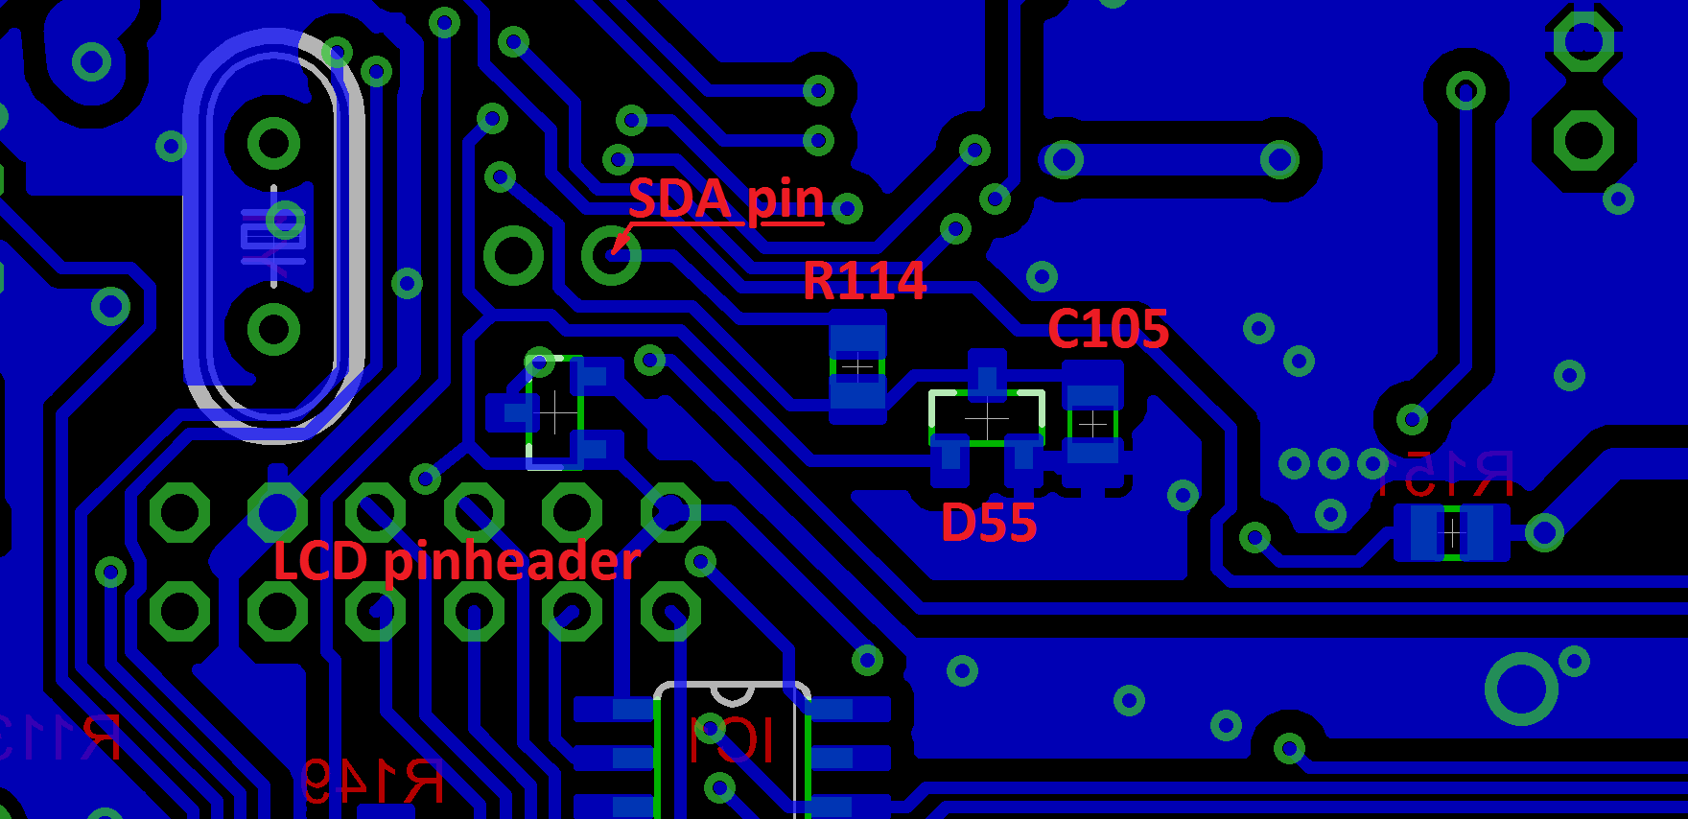
Bottom side (matches top, mirrored of real):
- R114 - 10k protection resistor
- D55 - BAV99 protection didode
- C105 - 1nF filter capacitor

