BT module

Revised serial commands (02-07-2014 and up – DB)
Changes:
* only allow local (rs-232 side) module re-configuration when BT is unconnected
* no module reboot on BT disconnect.

New commands:
- $$$
- SU,19$0D
- S-,Vems$0D
- ST,0$0D
- SQ,16$0D
- SA,4$0D
- SP,1234$0D
- R,1$0D
Measure USB voltage, check BT module’s LED
Check communication on Android between VemsDisplay and V3.

VEMS Bluetooth RS-232 adapter

This device can turn an Android phone or tablet into a dashboard with Vems Display(vems.hu/android) or use VemsTune without serial cable. There is two way to +5V supply the adapter, one is to feed the +5V on the dsub9 pin 9, the other way is to feed via a micro-USB cable using a standard cigar lighter USB charger or USB host. Do NOT use both method! Before using the adapter, pair it with the desired device. Do not supply via USB, if you connect to controller where the attached paper say “The serial cable is ready for Bluetooth or Wi-fi”

+5V supply (consumption approximately 30-40mA)
+5V to pin 9 eg. EC36/28(not EC36/29) +5V form USB Do NOT use both!
charger/plug/
USB host(PC, notebook, Android USB)

Every adapter has unique name, you can find it on the label.
The default PIN code is 1234.

Changing PIN code

If you ever need to change the PIN code, do the following.
- Build or use a cross linked serial cable
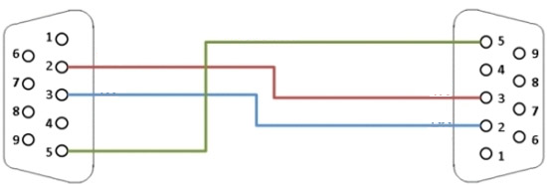
dsub9 female dsub9 female

- Apply +5V supply and connect it to your PC via RS-232 serial cable. Use a terminal program with these settings: 19200 8N1, type the following commands(Hit Enter in the end of each line):
  - $$$
  - SP,XXXX Where XXXX is the new pin code(up to 20 digits, use only 0-9)
  - ---

